Press Release

VariantWorld.2018 was successful again
The high number of participants at the VariantWorld.2018 in Leipzig again demonstrated that variant management and reduction of complexity play a key role in product development. During the two-day specialist conference, over 70 visitors, particularly from the automotive industry, focused on new solution approaches for variant management in software and systems engineering.
Erlangen, 04/24/2018 – On April 17 and 18, the VariantWorld took place for the second time. The key topic of this conference was processes and methods for the management of variant diversity and product complexity. Method Park and the German publisher HANSER Verlag invited participants to join this conference in Leipzig. Many best practices demonstrated how to put individual approaches of variant management into business practice. Prof. Ina Schäfer of the TU Braunschweig took on responsibility for the conference management in this year.
Method Park contributed with two presentations to the conference program. Dr. Tobias Kästner, Expert Engineer IoT, presented the topic “Agile Hardware Development as Enabler for Agile Systems Engineering”. In his presentation, Dr. Holger Höhn, Manager of Method Park Consulting GmbH, demonstrated how to use approaches of the maturity model Automotive SPICE® for managing variants and reuse product components within the context of variant management.
With a so-called solution trail, the organizers of VariantWorld.2018 chose an interactive format: During the first conference day, participants were able to get informed there about six individual solution approaches at several stopovers and ask experts their questions. On the second conference day, the individual topics of participants were clustered into topic areas and discussed in individual open spaces.
During the conference breaks, representatives of organizations such as Hilti, Bosch, Daimler, Schaeffler, Continental or VW discussed trends and tools for variant management with the exhibitors (among others, Prostep, pure-systems and Method Park).
Number of characters (spaces included): 2.067
About Method Park
Method Park is specialist for innovative software and systems engineering in the safety-critical environments of the medical and automotive industries. Method Park’s portfolio includes consulting and engineering services, a comprehensive training program and the process management tool “Stages”.
Method Park was founded in 2001. On a worldwide basis, the company has coached its customers on process optimization, compliance to industry-specific standards and legal regulations. It has also consulted on the management of projects, products and quality assurance. Method Park offers a practice-based training program on all current topics of software and systems engineering. Method Park offers training at its locations in Germany and other European countries, the US and Asia.
With “Stages”, Method Park offers an individually customizable process management tool which supports its users on the definition, communication and application of complex processes.
The company group has locations in Erlangen, Frankfurt on the Main, Hanover, Munich and Stuttgart as well as in Detroit, Miami and Pittsburgh in the US. With around 170 employees, Method Park generated an operative turnover of about 16.3 million euros in 2017.

For further information please contact:
Dr. Christina Ohde-Benna, PR-Assistant
Method Park Holding AG, Wetterkreuz 19a, 91058 Erlangen, Germany
Christina.Ohde-Benna@methodpark.de www.methodpark.de

Available pictures:
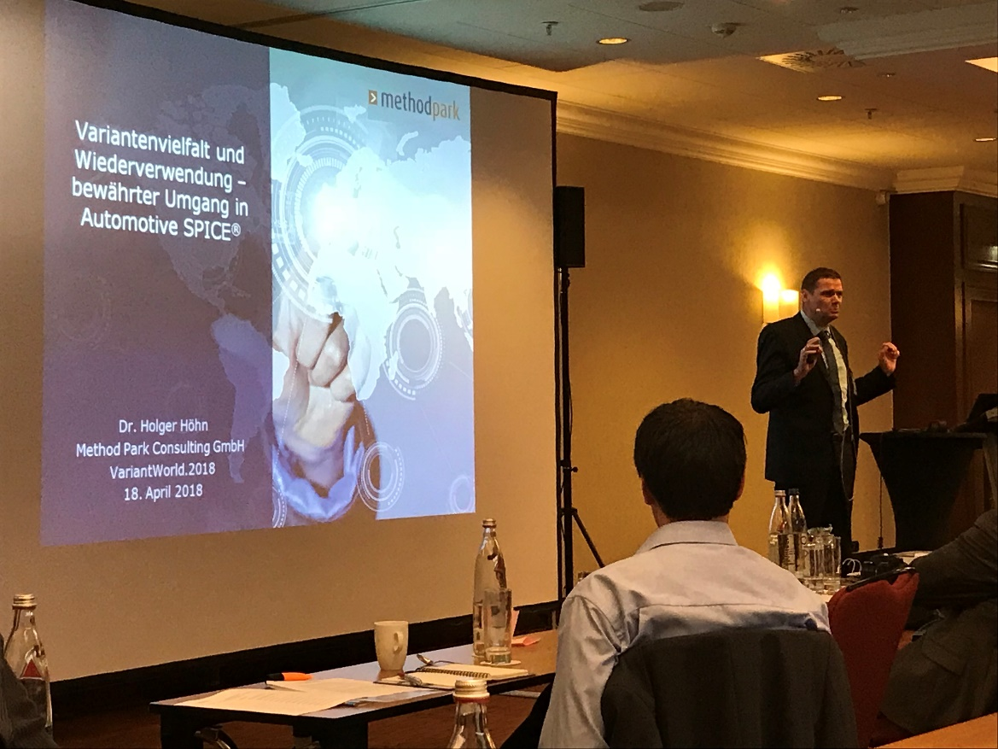
At the VariantWorld.2018, Dr. Holger Höhn, Manager of Method Park Consulting GmbH, gave a presentation on variant diversity and reuse.

