Press Release

Method Park wins the Bavarian Entrepreneur Award
Erlangen-based company ranked first in the category ‘achiever’.
The Bavarian Association of Savings Banks certifies Method Park the potential for market leadership and highlights the special success in turnover of the software and systems company, based in Erlangen.
Erlangen, July, 16, 2018 – During the festive gala event, completing the 16th Entrepreneurs Conference Bavaria, Method Park was awarded with the Bavarian Entrepreneur Award thursday evening in the Nuremberg Convention Center. With this award, the Bavarian Association of Savings Banks honors special achievements and success of the company which has achieved excellent growth with its software and systems engineering within a short time and has become market leader in the automotive industry with its process management tool “Stages”.
The award was presented to Prof. Dr. Bernd Hindel, Method Park CEO and founder of the Method Park Group, and Dr. Martin Geier, COO of the company, by Dr. Markus Wiegelmann, Chief Financial Officer of the Bavaria State Bank. In his laudation, Dr. Wiegelmann particularly highlighted the success Method Park achieved for the management of complex processes of its customers. Particularly large companies are only able to face future challenges with efficient processes.
Prof. Dr. Bernd Hindel is proud to receive the award. “It shows that it is worth persistently pursuing an entrepreneurial idea. Today, companies face complex processes and Method Park had decades of experience with the management of business and development processes, when these processes were not as complex as today.”
The business success proves him right. In 2016, Method Park increased its turnover by 16 percent. In 2017, the company group generated a turnover of 16.4 million euros. Six of the ten worldwide largest automotive manufacturers use the tool Stages, developed by Method Park, for the management of complex development and production processes; over 30,000 people use Stages on a daily basis.
The Bavarian Entrepreneur Award is awarded for exemplary achievements in the development of innovative and sustainable business ideas and for outstanding successes in the establishment of companies. With this award, the Bavarian Association of Savings Banks supports entrepreneurship in Bavaria and promotes the economic culture of innovation and sustainability.
A nomination procedure decides upon participation. From the submitted proposals and in several valuation rounds, the Entrepreneur Award Jury selects three winners for five categories each: concept, start-up, achiever, succession and life’s work. A special award is presented for exceptionally responsible entrepreneurial activities. The nominated company’s representatives are interviewed by the jury, which then selects the award winners for each of the individual categories.
Number of characters (space characters included): 2864 characters
For further information see the website of Sparkassenverband Bayern: https://sparkassenverband-bayern.de/Engagement/Bayerischer-Gruenderpreis/Der-Bayerische-Gruenderpreis-2018/Method-Park-Holding-AG
On YouTube you find a short video (3:54 min) on Method Park, specially made for the Bavarian Entrepreneur Award: https://www.youtube.com/watch?v=7XvCTxJCbeE&t=76s
About Method Park
Method Park is specialist for innovative software and systems engineering in the safety-critical environments of the medical and automotive industries. Method Park’s portfolio includes consulting and engineering services, a comprehensive training program and the process management tool “Stages”.
Method Park was founded in 2001. On a worldwide basis, the company has coached its customers on process optimization, compliance to industry-specific standards and legal regulations. It has also consulted on the management of projects, products and quality assurance.
Method Park offers a practice-based training program on all current topics of software and systems engineering. Method Park offers training at its locations in Germany and other European countries, the US and Asia.
With “Stages”, Method Park offers an individually customizable process management tool which supports its users on the definition, communication and application of complex processes.
The company group has locations in Erlangen, Frankfurt on the Main, Hannover, Munich and Stuttgart as well as in Detroit, Miami and Pittsburgh in the US. With around 170 employees, Method Park generated an operative turnover of about 16 million euros in 2017.
For further information please contact:
Dr. Christina Ohde-Benna, PR-Assistant
Method Park Holding AG, Wetterkreuz 19a, 91058 Erlangen, Germany
Christina.Ohde-Benna@methodpark.de www.methodpark.com
Available pictures:
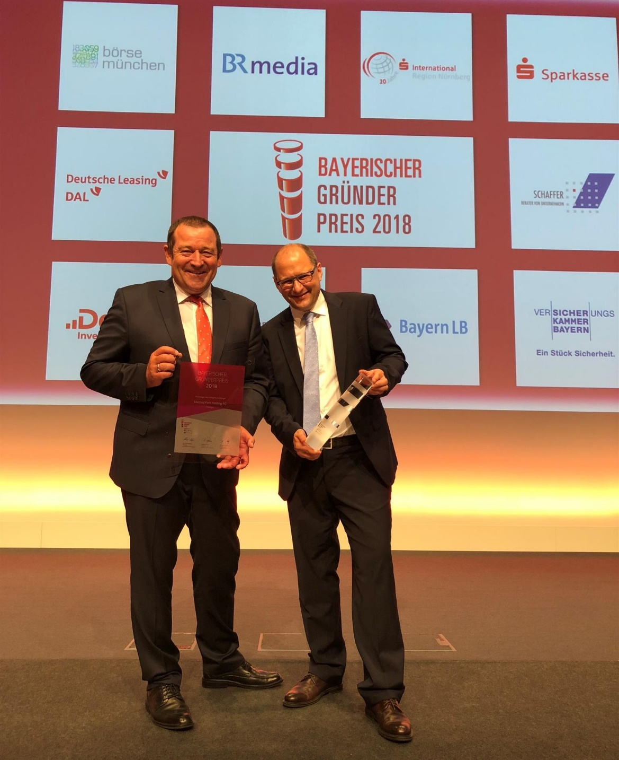
Prof. Dr. Bernd Hindel (Method Park CEO) and Dr. Martin Geier (Method Park COO) are pleased about the Bavarian Entrepreneur Award.

