Press Release

App for Automotive SPICE® V3.1 available
Method Park updates and optimizes free app
Method Park adjusted its app “Automotive SPICE Guide” to the changes of the process assessment standards V3.1 and fundamentally improved the app’s usability.
Erlangen, September 18, 2018 – Method Park provides an update of its Automotive SPICE® app. The new app includes the entire content of the versions V3.1 and V2.5 as well as the VDA scope so the user can switch between the Automotive SPICE® versions and the VDA scope quick and easy.
Charts give an overview of traceability requirements of Automotive SPICE® while all processes are described with purpose, process results, output work products and basic methods. Additionally, the app includes all capability levels (0 to 5): boards show process attributes and generic practices and explain the assessment mechanism.
In addition to the changes in content, the Method Park Automotive SPICE® experts also simplified the app’s usability. The pages of the new app are optically refined and the visualization of Automotive SPICE® content is improved. With the new navigation, it is easier for the user to navigate through the app and to find contents even quicker.
This Method Park app is now available for iOS-based systems and Android-based handhelds from iTunes and the Google Playstore. Download and installation is for free.
The new app is part of the consulting services Method Park has offered its customers for many years, on all questions around Automotive SPICE®. It complements a pocket guide for the new version V3.1 also offered by Method Park. Furthermore, the company which is based in Erlangen has been the exclusive training provider of the VDA on Automotive SPICE® courses since 2017. Method Park has become market leader in the field of assessor training and Automotive SPIC® assessments.
Number of characters (space characters included): 1.836 characters
About Method Park
Method Park is specialist for innovative software and systems engineering in the safety-critical environments of the medical and automotive industries. Method Park’s portfolio includes consulting and engineering services, a comprehensive training program and the process management tool “Stages”.
Method Park was founded in 2001. On a worldwide basis, the company has coached its customers on process optimization, compliance to industry-specific standards and legal regulations. It has also consulted on the management of projects, products and quality assurance.
Method Park offers a practice-based training program on all current topics of software and systems engineering. Method Park offers training at its locations in Germany and other European countries, the US and Asia.
With “Stages”, Method Park offers an individually customizable process management tool which supports its users on the definition, communication and application of complex processes.
The company group has locations in Erlangen, Frankfurt on the Main, Hannover, Munich and Stuttgart as well as in Detroit, Miami and Pittsburgh in the US. With around 170 employees, Method Park generated an operative turnover of about 16 million euros in 2017.
For further information please contact:
Dr. Christina Ohde-Benna, PR-Assistant
Method Park Holding AG, Wetterkreuz 19a, 91058 Erlangen, Germany
Christina.Ohde-Benna@methodpark.de www.methodpark.com

Available pictures:
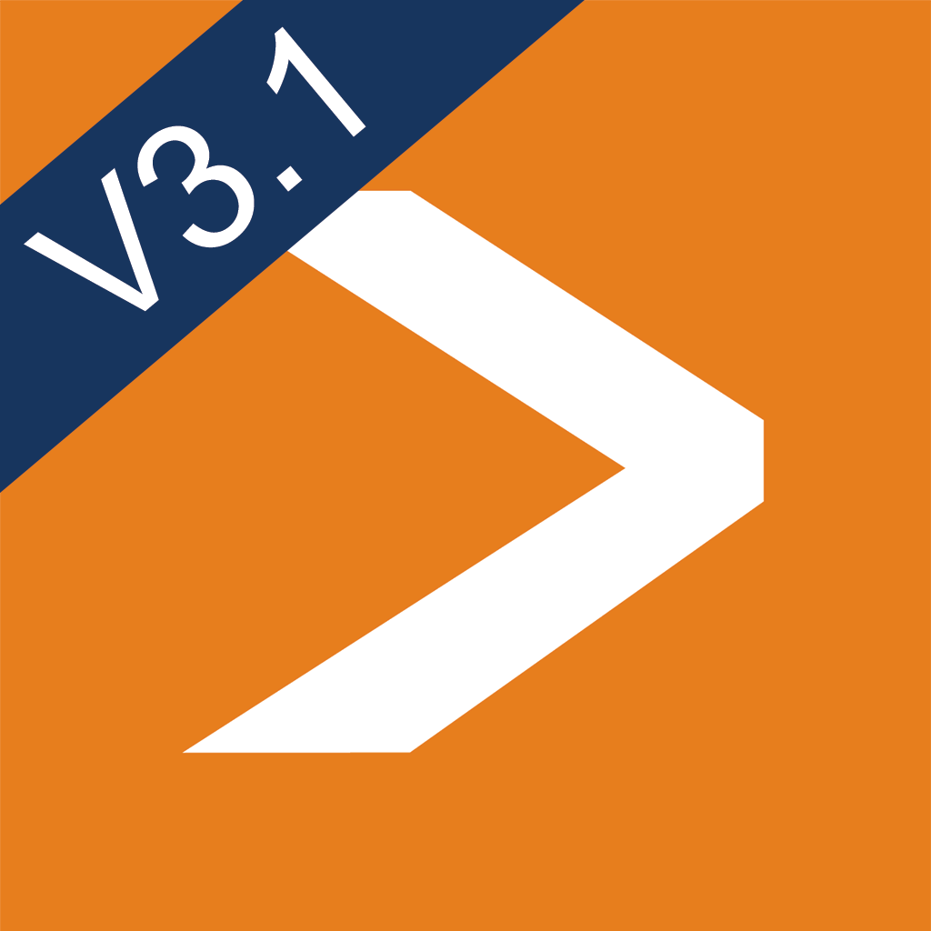
Icon of the new app Automotive SPICE Guide

