Press Release

Method Park certified twice by Great Place to Work®
Method Park continues to be one of the most attractive employers in the German SME sector
The Erlangen-based consulting company receives awards from "Great Place to Work®" in two categories - "Best Employer in ICT" and "Bavaria's Best Employers". This puts Method Park in the circle of well-known companies such as Cisco or Mercedes-Benz.
Erlangen, May 6, 2021 - For the second time after 2009, Method Park receives the coveted "Great Place to Work®" seal 2021. Method Park takes the 28th place in the category "Best Employer in ICT" among 100 winning companies. In the category "Bavaria's best Employers", Method Park made it to rank 15. A total of 1,034 medium-sized organizations took part in the competition.

Valuable impulses
"The excellent results in the anonymous employee survey make us highly optimistic," said Prof. Dr. Bernd Hindel, CEO of the Method Park Group, on Wednesday afternoon after receiving the award, whose presentation took place as an online award event. "Especially in exceptional situations like the Covid-19 pandemic, it is important to pull together - combined with continuous development. That's why this certification is particularly valuable to Method Park."

Respect, trust, and team spirit
"Good employers have one thing in common," says Sebastian Diefenbach, Head of Client Consulting at Great Place to Work®, "they are committed to credible, fair leadership and the active development of employees. Respect, trust, and team spirit are part of the corporate culture to a large extent."
The Method Park guiding principle is primarily characterized by its corporate structure: Flat hierarchies and short decision-making structures are part of the workplace culture; all employees are on a first-name basis with each other. A family atmosphere is just as important here as a good work-life balance. A wide range of further training opportunities is also provided.

Withstanding the shortage of skilled workers
According to a survey by Bitkom e. V., around 86,000 positions in the IT labor market remained unfilled at the end of last year - 31 percent fewer than the historic high of 124,000 from the previous year. The Covid-19 pandemic has slightly dampened the problem of the shortage of skilled workers, but the figures are still high. That's why certifications are an important component in increasing a company's attractiveness and standing out from the crowd.

The award
The award from the worldwide operating Great Place to Work® Institute was based on an anonymous and representative survey among Method Park employees. Topics included credibility, respect, fairness, pride, and team spirit. In the second part, the culture audit, the most important facts, figures, and data were determined.
Number of characters (space characters included): 2,768
About Great Place to Work®
Great Place to Work® is an internationally operating, independent research and consulting institute that supports over 6,000 companies from 60 countries worldwide in developing an attractive corporate and workplace culture. Every year, Great Place to Work® recognizes very good employers internationally, nationally, regionally, and industry-specifically for their performance based on anonymous employee surveys and corporate culture analysis. The German institute, headquartered in Cologne, was founded in 2002 and currently employs around 90 people.
For more information, visit: https://www.greatplacetowork.de/beste-arbeitgeber/great-place-to-work-zertifizierung/ and https://www.greatplacetowork.de/workplace/item/3707/method+park
About Method Park
Method Park specializes in complex product engineering in the environments of the automotive, medical, and aerospace industries. Method Park's portfolio includes consulting and engineering services, a comprehensive training program, and the process management tool "Stages".
Method Park was founded in 2001. On a worldwide basis, the company has coached its customers on process optimization, compliance to industry-specific standards and legal regulations. It has also consulted on the management of projects, products, and quality assurance.
Method Park offers a practice-based training program on all current topics of software and systems engineering. Method Park offers training at its locations in Germany and other European countries, the US and Asia.
With "Stages", Method Park offers an individually customizable process management tool which supports its users on the definition, communication, and application of complex processes.
The company group has locations in Erlangen, Munich, Stuttgart, Frankfurt on the Main, Hamburg, and Berlin as well as in Detroit, Miami, and Pittsburgh in the US and Shanghai in China. Today, about 230 employees work for Method Park. In 2020, Method Park generated an operative turnover of about 25 million euros.
For further information, please contact:
Dr. Christina Ohde-Benna, PR-Assistant
Method Park Holding AG, Wetterkreuz 19a, 91058 Erlangen, Germany
Christina.Ohde-Benna@methodpark.de www.methodpark.com

Available pictures:
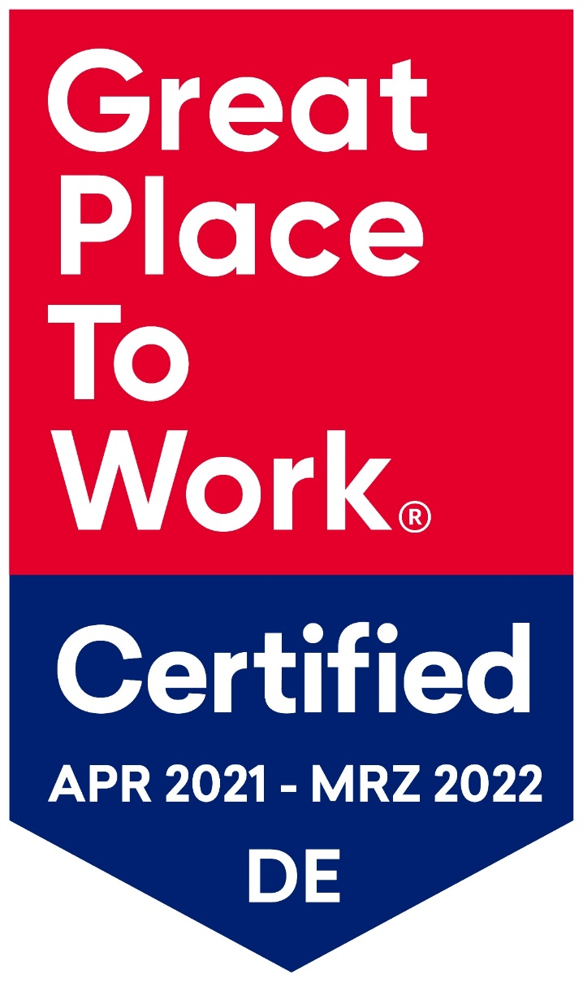
Caption: Great Place To Work® Certified Seal April 2021 - March 2022
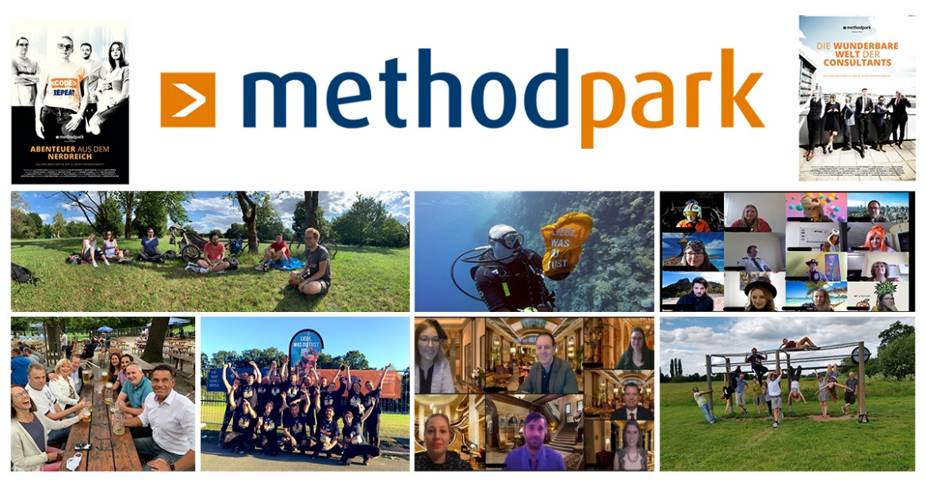
Method Park’s contribution to the collage of all Great Place To Work® Winners

